

CAPSTONE PROJECT REPORT

On

**FYNALYCUS**

[www.finalycus.com](http://www.finalycus.com/)

**Submitted by:**

KC269

**Under the Guidance of**

Miss Sandeep Kaur

UID: 23614

Assistant Professor

**School of Computer Science & Engineering Lovely Professional University, Phagwara**

***(August-November 2019)***

**CERTIFICATE**

This is to certify that the group **KC269** bearing the candidates as mentioned in the following page has worked to their best on **Capstone Project** titled, **FINALYCUS** under my guidance and supervision. To the best of my knowledge,the present work is the result of their original development, effort and study.

**Signature and Name of the Supervisor**

**Designation of the Supervisor**

**School of Computer Science and Engineering**

**Lovely Professional University**

**Phagwara, Punjab.**

**Date:**

**DECLARATION**

We, **Members of group KC269**, students of **COMPUTER SCIENCE ENGINEERING** under CSE/IT Discipline at, Lovely Professional University, Punjab, hereby declare that all the information furnished in this project report is based on our own intensive work and is genuine.

|  |  |  |  |
| --- | --- | --- | --- |
| **S No** | **NAME** | **Registration Number** | **JOB/Role** |
| 1 | S Pavan Kumar Reddy | 11610083 | Web Designing |
| 2 | M Veera Raju | 11601861 | Algorithm, Coding, Analysis |
| 3 | Boyina Navakanth | 11607556 | Algorithm, Coding, Analysis |



**Date:**

Note: Roles are distributed for the sake of parallel execution and equal contribution of each and everyone in the project though everyone will contribute to each module of the project and work on it when needed

**ACKNOWLEDGEMENT**

We take this opportunity to express our profound gratitude and deep regards to my guide Miss Sandeep Kaur from Lovely Professional University and the mentors for their exemplary guidance, monitoring and constant encouragement throughout the project. The blessing, help and guidance given by her to time shall carry us a long way in the journey of life on which we are about to embark.

We are obliged to staff members of LPU, for the valuable information provided by them in their respective fields. We are grateful for their cooperation during the period of our training.

Lastly, we thank almighty, our parents and teachers for their constant encouragement without which this assignment would not possible.

**TABLE OF CONTENT**

**1. Introduction**

1.1. Objective of the project

1.2. Description of the project

1.3. Scope of the project

1. **Objectives**
2. **Profile of the problem Rational /Scope of the Study (problem Statement)**
3. **Existing System**

4.1. Introduction

4.2. Existing Software

4.3. DFD for present System

.4. What’s new in the system developed

**5. Problem Analysis**

5.1. Problem definition

5.2. Feasibility Analysis

5.3. Project Plan

**6. Software Requirement Analysis**

6.1. Introduction

6.2. General Description

6.3. Software Requirements

**7.Design**

7.1 System Design

7.2 Design Notations

7.3 Detailed Design

7.4 Flow charts

* 1. Pseudocode

**8.Testing**

8.1. Functional Testing

8.2. Structural Testing

8.3. Levels of Testing

8.4. Testing of Project

**9.Implementation**

9.1 Implementation of the Project

9.2 Conversion Plan

9.3 Post-Implementation and Software maintenance

**10. Project Legacy**

* Current Status of the project
* Remaining Areas of concern
* Technical and Managerial lessons learnt

**11. User Manual: A complete document (Help Guide) of the software developed*.***

**12. Source Code (wherever applicable) or System Snapshots**

**13. Bibliography**

**1.INTRODUCTION**

**1.1 Objective of the Project**

The main objective of the project is to create a web-based interface for various financial operations including stock market analysis. Financial planning is very essential for an individual as it helps to maintain consistent savings ratio even in this world of constant inflation. One can save money with the help of saving on taxes. Savings on taxes is one method which yields good results in having an efficient financial plan. Everyone these days are aware of income tax and their liability towards taxes, and due to this reason people remain very keen to calculate their income tax. Below is the brief of how an individual can calculate their tax liability and which tools can they use to calculate it. Income tax calculator is one such tool with the help of which an individual can calculate their income tax liability. Income tax calculators take every income head into account and they require some information to be filled in by people calculating their tax. It takes various deductions available to an individual and above calculations; it provides knowledge about certain limits which can prove very beneficial in the tax estimation scenario. One can calculate their income tax refund with the help of using income tax calculator as well.

**1.2 Description of the Project**

FINALYCUS (FINANCE + ANALYTICS + ABACUS)

FINALYCUS is a website which provides easy access to the people and small-scale industries to perform various financial operations. Not only this we will also provide stock marketing analysis. Predicting how the stock market will perform is one of the most difficult things to do. There are so many factors involved in the prediction – physical factors vs. physiological, rational and irrational behaviour, etc. All these aspects combine to make share prices volatile and very difficult to predict with a high degree of accuracy.

Data Science is a game changer in this domain. Using features like the latest announcements about an organization, their quarterly revenue results, etc., machine learning techniques have the potential to unearth patterns and insights we didn’t see before, and these can be used to make unerringly accurate predictions. Along with this we will also provide latest trends in the market to help investors with a sack of terminologies.

**1.3 Scope of the Project**

FINALYCUS is a unique platform compared to others which is available for all and helps in various financial operations like stock markets, loans, chit funds, EMI, Investment. The user feels very easy to find his solutions in our platform.

Analysis of stocks using data mining will be useful for new investors to invest in stock market based on the various factors considered by the software. Stock market includes daily activities like Sensex calculation, exchange of shares. The exchange provides an efficient and transparent market for trading in equity, debt instruments and derivatives. Along with the unique user-friendly web interface for all financial calculations at one place. All we need is the device with internet connectivity.

**2. OBJECTIVES**

**Objective 1**

The user will be able to calculate the Income Tax with respect to many factors and rules.

**Objective 2**

loans and EMI’s are the most used terms now a days. So, we have decided to implement Loan and EMI calculator through which people can check whether it is profitable or not.

**Objective 3**

The clients will also get statistical stock market analysis which helps them to invest wisely.

**Objective 4**

To deploy a Web page to perform all these operations.

**4. Existing System:**

**4.1 Introduction:**

In the existing system when we want to see the stock prediction we need to pay some money. Only the rich people or people you can effort it was able to use perks of stocks prediction. Spending such a huge amount can be sometimes not worthy. When we want to calculate our taxes or file the ITR. We hire an accountant to do the task.

**4.2 Existing Software**

There are some good websites which provide stocks and stock prediction but there are not free. There are websites which provide us to calculate our taxes. And There are many other websites to see loan approval prediction also for emi calculation.

But we at FINALYCUS provide a solution all the problems at only one stop.

The following are the features of FINALYCUS:

* The user can access to our website anytime from any place around the globe using their Laptops, Phones, I pad, Tablets.
* loans and EMI’s are the most used terms now a days. So, we have decided to implement Loan and EMI calculator through which people can check whether it is profitable or not.
* The clients will also get statistical stock market analysis which helps them to invest wisely.
* Clients can also go through various trends w.r.t regional market which makes their investments profitable.
* The user can also calculate the chit funds with various parameters.
* The user will be able to calculate the Income Tax with respect to many factors and rules.
* The User Will get subscribed from website to get instant updates from us at first.

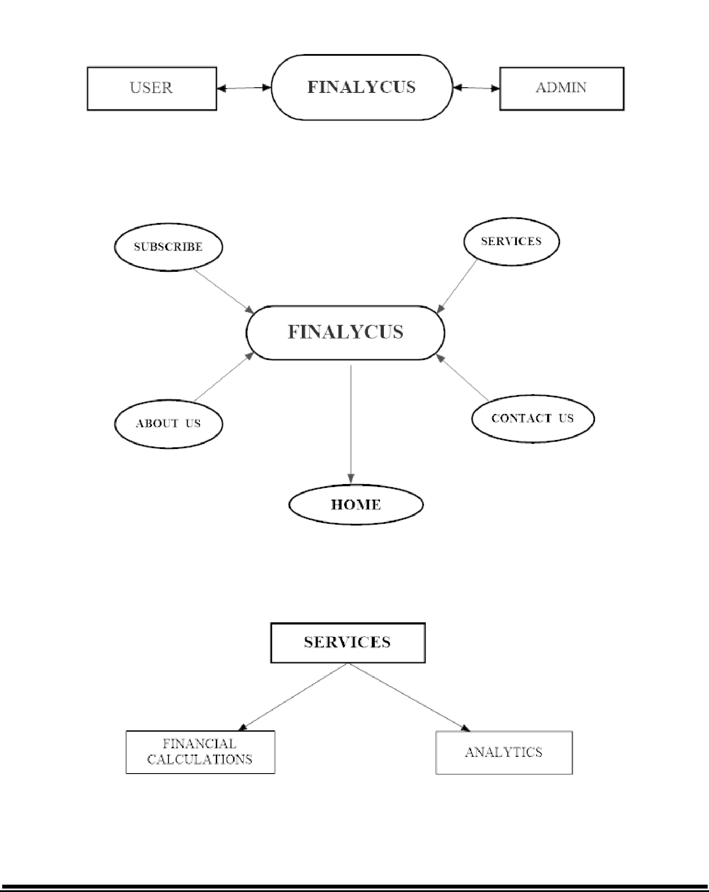**4.3 DFD for present System**

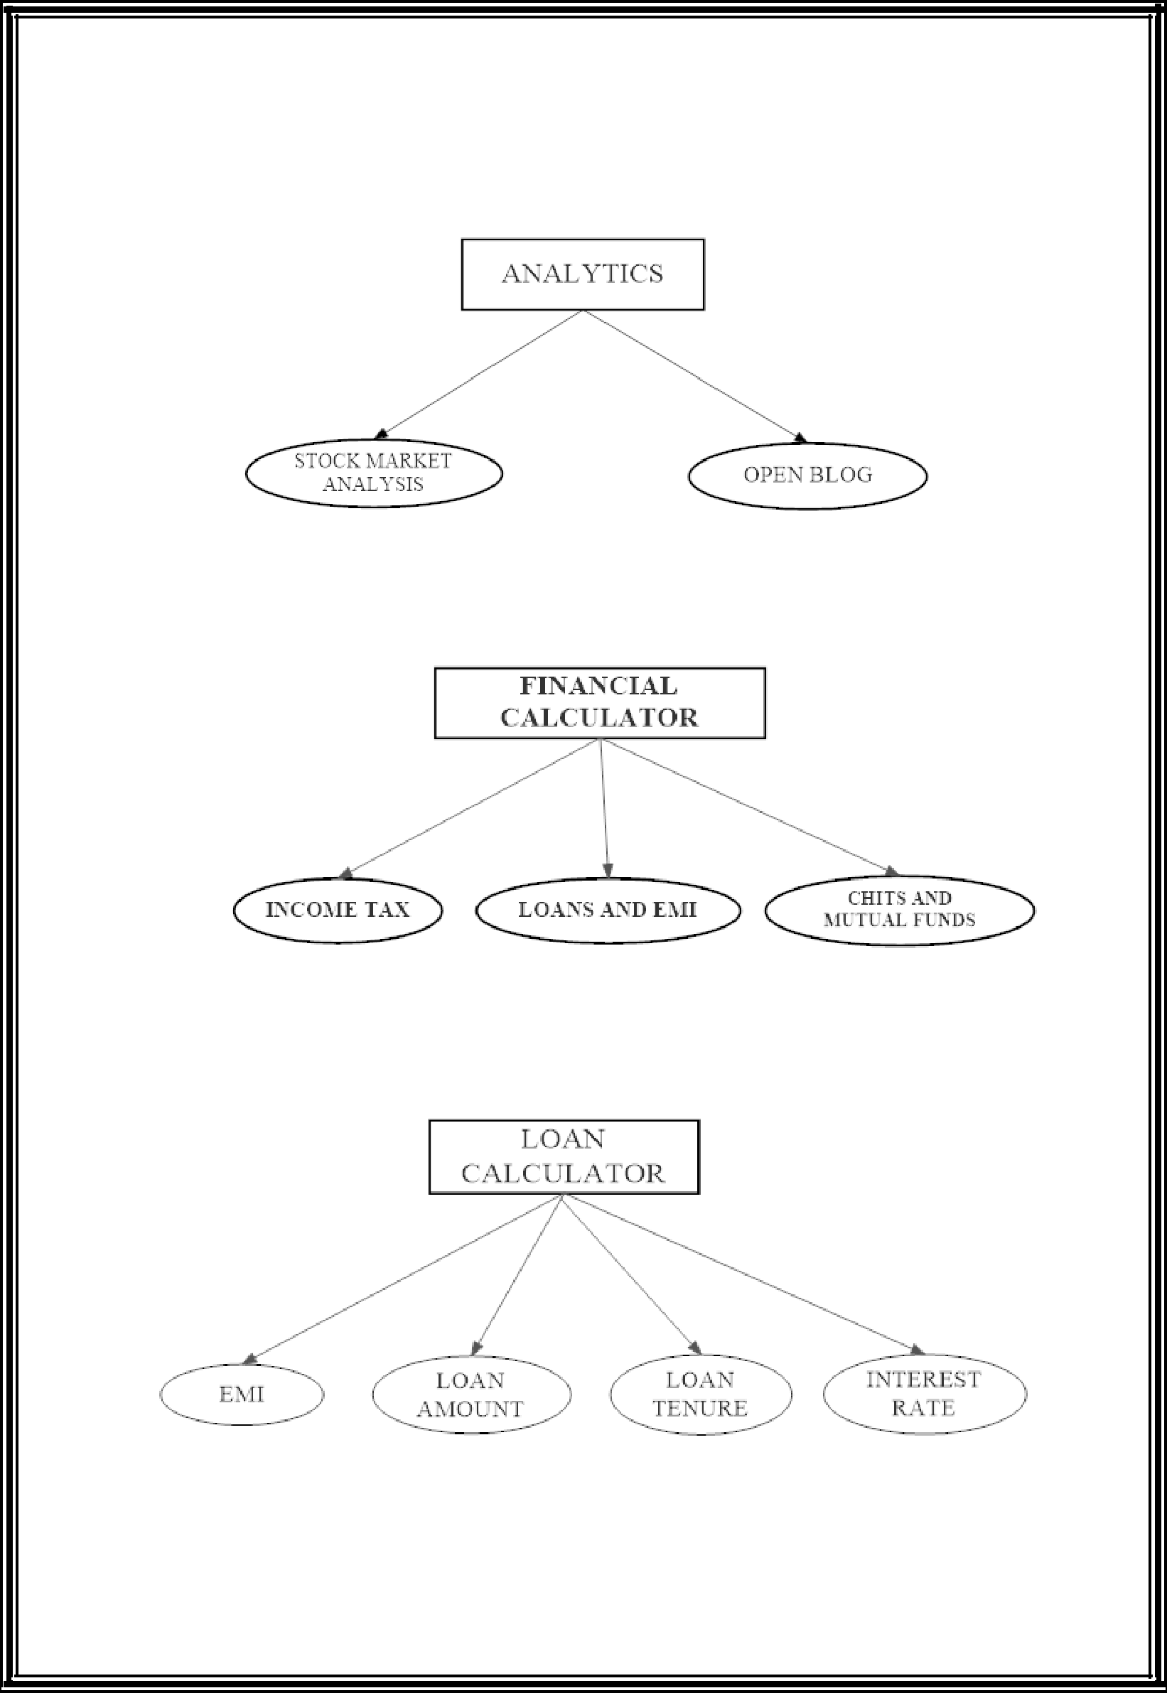

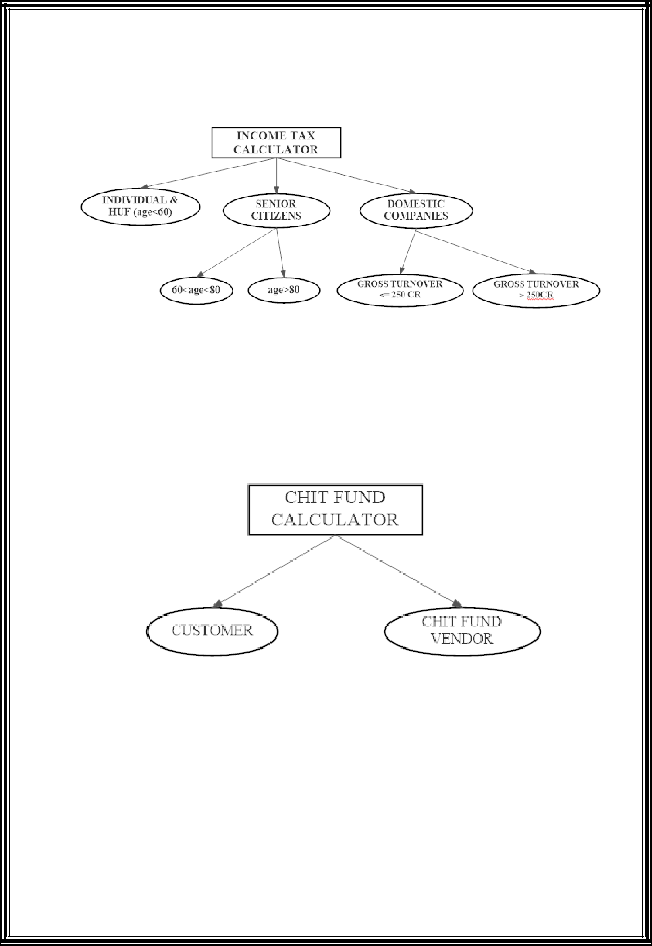

**5.Software Requirement Analysis**

**5.1 Introduction:**

Software requirement is a functional or non-functional need to be implemented in the system. Functional means providing service to the user. Software requirement can also be a non-functional, it can be a performance requirement. For example, a non-functional requirement is where every page of the system should be visible to the users within 5 seconds.

So, basically **software requirement is a**

* Functional
* Non-functional

|  |  |  |  |
| --- | --- | --- | --- |
| Sr. No. | Description | Notes | |
| 1 | User | User is one who visits our website | |
| 2 | Functional Requirements | 1. A module for   user to sign up   1. A module for user login. 2. A module for Client to post job 3. A module for finding info of stocks and its predictions. 4. A module for user to calculate EMI 5. Module for to see loan prediction 6. Module for viewing loan repayment and tax calculations | |
| 4 | Security Requirements | Data backup should be there and be regularly updated. The access to the system should be through authorized login only. | |
| 5 | Non-Functional  Requirements | a. | Website being available all the time. |
|  |  | b. | Well-designed pages which make our website user friendly. |
|  |  | c. | Foster ideal User Experience by correct placement of modules  (buttons etc.) |
|  |  | d. | Usage of validations.in different forms. |
|  |  | e. | Quick loading of the pages. |

**5.2 GENERAL DESCRIPTION:**

A software requirements specification (SRS) is a description of a software system to be developed, it’s defined after business requirements specification (CONOPS) also called stakeholder requirements specification (StRS) other document related is the system requirements specification (SyRS).

**5.3 Software Requirements**

The database/website may get crashed at any certain time due to virus or operating system failure. Therefore, it is required to take the backup.

The website should be hosted on a server that can provide adequate response time.

* Minimum 16-bit computer
* Minimum 2GB HDD
* Minimum Pentium III processor, 500 MHz
* Minimum 256MB RAM

The development of the system will be constrained by the availability of required software such as web servers, database and development tools. The system requires internet in order to access the web services. The database should have backup capabilities.

The system must be designed to allow web usability. That is, the system must be designed in such a way that will be easy to use and visible on most of the web browsers